

Name:

WAQAS ASHIQ

Roll No:

Fa11-Ciit-DDP-BCS-201

Section:

C

Submitted To:

MR.HAFIZ RIZWAN

**INSERTION IN DATABASE WITH SQL QURIE:**

INSERT INTO Employee(id,First_name,Last_name,Address,Phone_no,Mobile_no,Designation,Salary,Age,Email_id,Joinig_date)

VALUES('1','WAQAS','ASHIQ','LAHORE','1122','03217067743','DIRECTOR','40000','22','TRACK_FORU@YAHOO.COM','2012')

INSERT INTO Employee(id,First_name,Last_name,Address,Phone_no,Mobile_no,Designation,Salary,Age,Email_id,Joinig_date)

VALUES('2','AWAIS','KARAMAT','LAHORE','5111','03218900088','MANAGER','30000','21','ORACLE@YAHOO.COM','2013')

INSERT INTO Employee(id,First_name,Last_name,Address,Phone_no,Mobile_no,Designation,Salary,Age,Email_id,Joinig_date)

VALUES('3','WALEED','SOHAIL','ISLAMABAD','3111','03217054411','ACCOUNTANT','25000','22','SAMEEDA@YAHOO.COM','2011')

INSERT INTO Employee(id,First_name,Last_name,Address,Phone_no,Mobile_no,Designation,Salary,Age,Email_id,Joinig_date)

VALUES('4','KAMRAN','KHAN','FAISALABAD','1134','03008056789','ACCOUNTANT','25000','23','ACCOUNTANT_FORU@YAHOO.COM','2010')

INSERT INTO Employee(id,First_name,Last_name,Address,Phone_no,Mobile_no,Designation,Salary,Age,Email_id,Joinig_date)

VALUES('5','NASIR','ALI','KABUL','0900','090078601','WELDER','20000','28','WELDER_FORU@YAHOO.COM','2010')

INSERT INTO Employee(id,First_name,Last_name,Address,Phone_no,Mobile_no,Designation,Salary,Age,Email_id,Joinig_date)

VALUES('6','NAVEED','AHMAD','FAISALABAD','1452','03004916511','PAINTER','200000','25','KARAMDIN@YAHOO.COM','2011')

INSERT INTO Employee(id,First_name,Last_name,Address,Phone_no,Mobile_no,Designation,Salary,Age,Email_id,Joinig_date)

VALUES('7','SOHAIB','MAQSOOD','FAISALABAD','7946','03464791652','PAINTER','18000','26','NOT PROVIDED','2006')

INSERT INTO Employee(id,First_name,Last_name,Address,Phone_no,Mobile_no,Designation,Salary,Age,Email_id,Joinig_date)

VALUES('8','ATHISHAM','ASHIQ','LAHORE','3146','0346792166','DOCTOR','45000','22','DOCTOR@YAHOO.COM','2009')

INSERT INTO Employee(id,First_name,Last_name,Address,Phone_no,Mobile_no,Designation,Salary,Age,Email_id,Joinig_date)

VALUES('9','RASHID','RAFEEQ','FAISALABAD','1654','4913','LABOUR','15000','28','RASHID@YAHOO.COM','2010')

INSERT INTO Employee(id,First_name,Last_name,Address,Phone_no,Mobile_no,Designation,Salary,Age,Email_id,Joinig_date)

VALUES('10','MUDASAR','ALI','LAHORE','8794','03544654813','LABOUR','15000','66','NOT PROVIDED','2009')

**DISPLAY ALL EMPLOYES:**

SELECT * FROM Employee

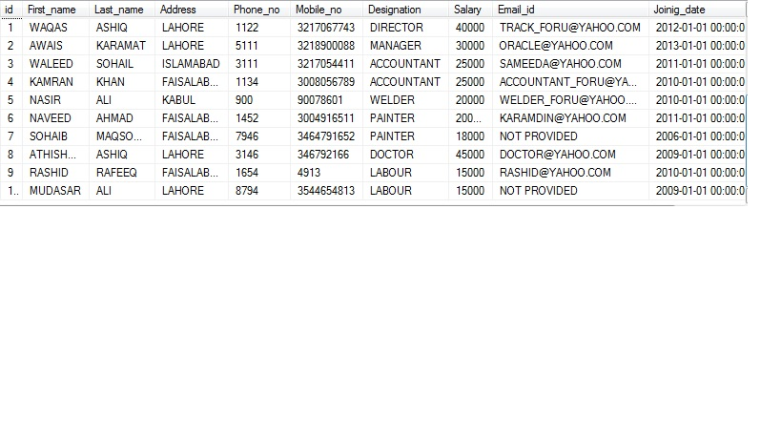

**EMPLOYES WITH SALAR MORE THAN 20000 AND LESS THAN 40000:**

SELECT First_name,Last_name from Employee where Salary>=20000 and Salary<=40000

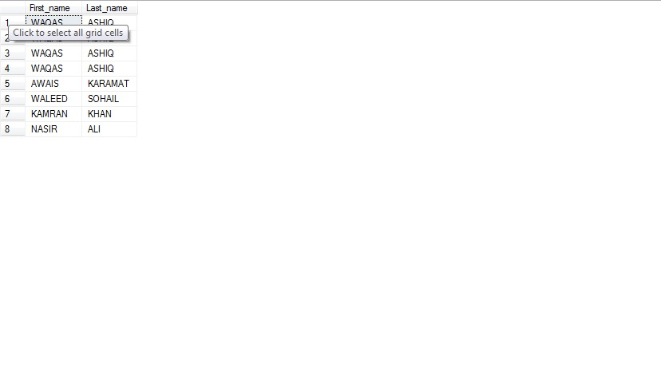

**EMPLOYES WITH AGE MORE THAN 60:**

SELECT First_name,Last_name,Designation from Employee where Age>60

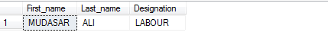

**EMPLOYES WITH JOINING DATE AFTER 2005:**

SELECT First_name,Last_name from Employee where Joinig_date>2005

